Science Quiz Study Sheet
Topic – Unit 1 – Light
Transparent – Objects that are transparent allow light to pass through directly without scattering the rays. Almost all of the light that falls on a transparent object passes through it so we can see what is on the other side. Transparent substances or objects are said to be clear. Air is transparent.
Translucent – Objects that let some light pass through, but scatter the rest, are translucent. Because most of the light is scattered, whatever is on the other side cannot be seen clearly and appears blurry. Frosted glass, often used in bathroom windows for privacy, is an example of a translucent material. Some light passes through the window, but the rest of the light is scattered.
Opaque – Opaque materials do not allow any light to pass through, and nothing can be seen on the other side. Opaque materials block light.
Light travels in a straight line. When it strikes an object it can be reflected, absorbed, or transmitted (passed through or scattered), or a combination of these.
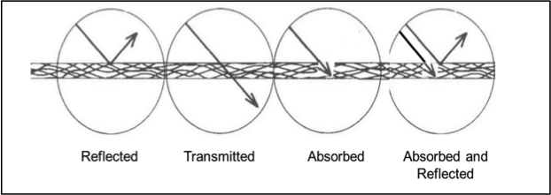

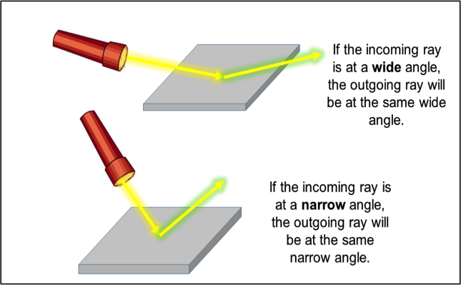
Rule of Reflection: Rays of light follow a simple reflection rule: the angle of the incoming ray is equal to the angle of the outgoing ray of light reflecting back.
Mirror Reflection: When you look in a mirror, you see light from your face reflected off of the mirror. The way light bounces off of mirrors can be predicted. Light reflects from a mirror at the same angle as it arrives.
How Light Refracts: When light passes from one kind of material (called a medium) to another, the light slightly changes speed and bends, or refractsIf you put a pencil in water, the light refracts, passing from air through glass and into water, causing the pencil to appear bent.
